Food Management System

Version <1.0>

Revision History

|  |  |  |  |
| --- | --- | --- | --- |
| **Date** | **Version** | **Description** | **Author** |
| <24/12/2020> | <1.1> | Final Draft | Nguyen Thi Ngoc Anh |

Table of Contents

1. Introduction 2

1.1 Purpose 2

1.2 Scope 2

1.3 Definitions, Acronyms, and Abbreviations 2

1.4 References 2

1.5 Overview 2

2. Flow of Events—Design 2

3. Derived Requirements 2

# Introduction

## Purpose

This document describes how the Display Order Status Use-Case is realized within the design model, in terms of collaborating objects.

## Scope

This document applies to the Food Management System which will be developed by TAT Restaurant.

## Definitions, Acronyms, and Abbreviations

None.

## References

None.

## Overview

In the following section, Use-Case Realization Specification of the Display Order Status Use-Case of the Food Management System is provided in detail. The first section is a textual description of the Use-Case specification. The following section contains diagrams (sequence and collaboration diagrams) describing how the use case is realized in terms of collaborating objects. The third section includes class diagrams with relationships that participate in the realization of the use case. The last section is an analysis of all requirements, such as non-functional requirements, on the use-case realization that are not considered in the design model, but that need to be taken care of during implementation.

# Flow of Events—Design

**2.1. Use Case Specification (script)**

|  |  |
| --- | --- |
| **Use Case** | Display Order Status |
| **Description** | Customer displays all status of order |
| **Actor(s)** | Customer |
| **Flows of Events** |  |
| **Basic Flow** | |
| 1. The user goes to display order status page.  2. The system get all status of orders in database as a list.  3. The system displays all order status in the list for the user | |
| **Alternative Flows** | |
| None. | |
| **Pre-conditions** | |
| None. | |
| **Post-conditions** | |
| A page lists all order status in database is displayed for the user. | |
| **Extension Points** | |
| None. | |

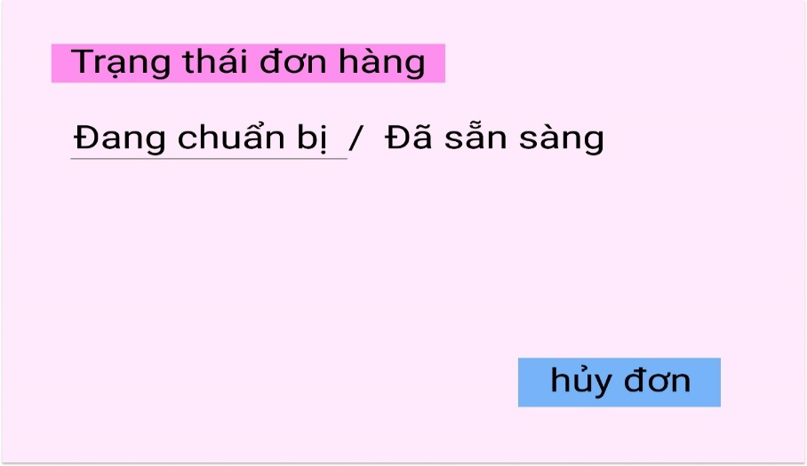

**2.2. Sequence Diagram:**

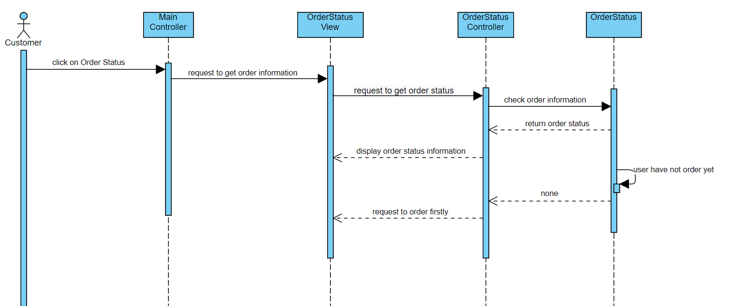

**2.3. Class Diagram:**

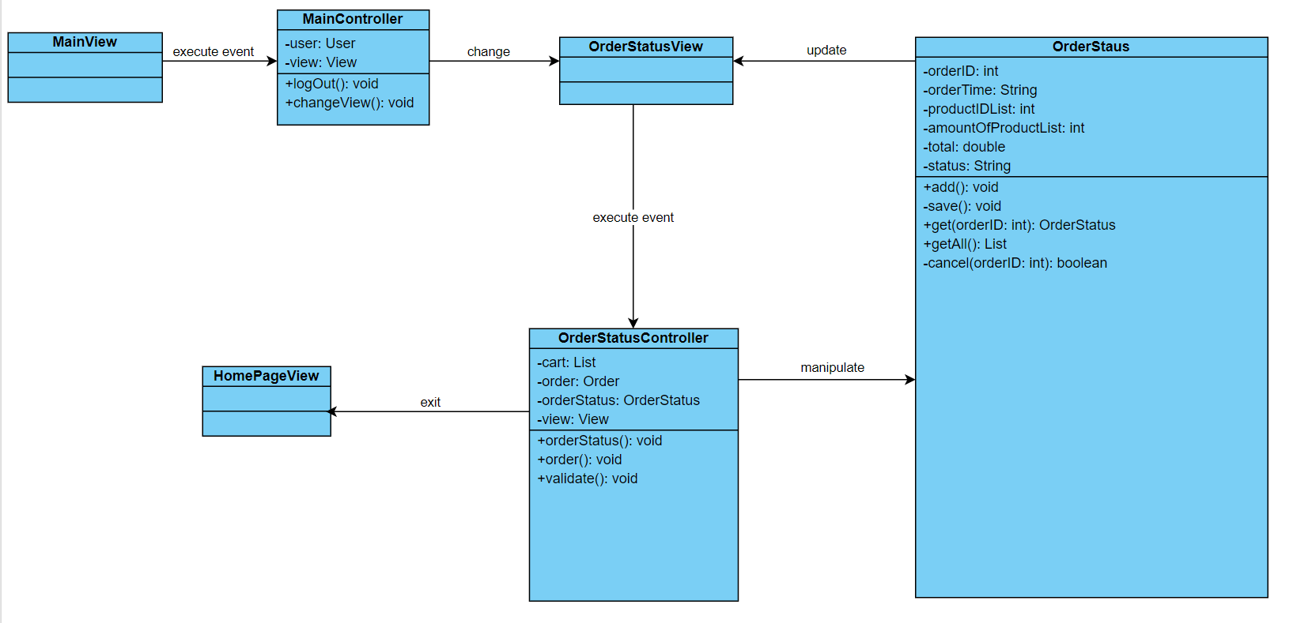

# Derived Requirements

None.